ARVAZAPP16 Can't connect to NFS server : 79894

NFS (Network File System) mounted storage refers to a distributed file system protocol that allows a client computer to access files over a network as if they were stored locally. In an NFS setup, a server hosts files and directories that can be accessed by multiple client machines over a network. The clients "mount" the shared directories from the NFS server, making them appear as if they are part of the client's own file system.

This setup is commonly used in environments where multiple computers need to share files and resources. NFS allows for centralized storage management, enabling easier access to data across different platforms and operating systems within a network. It's widely used in environments such as data centers, enterprise networks, and cloud computing infrastructures for its simplicity and efficiency in sharing files and resources.

Check disk usage

>> Df -h

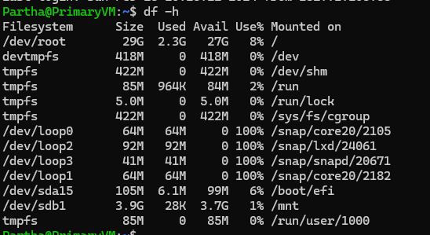

>> mount

This can list out what all files mounted in which location

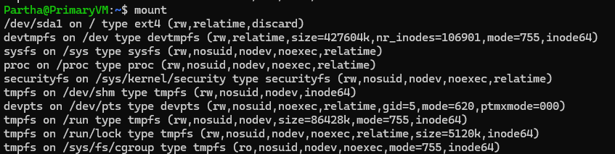

>> mount | grep nfs

This command will display all mounted filesystems, and the grep command filters out only those related to NFS shares.

If you see output lines with NFS filesystems, it means those shares are mounted. If you don't see any output lines containing NFS filesystems, then they are not mounted.



>> mount | grep /mnt/nfs_share

If you want to specifically check for a particular NFS share, you can grep for its mount point. For example, if your NFS share is mounted at /mnt/nfs_share



NOTE :- In NFS system there is a server (NFS server) which stores the files from server side, at root level file need to be create (/) and need to allow all permission n that directory (chmod 777).

NFS clients machines can access files folders from NFS server and can modify.

File will be present physically on NFS server but all NFS clients can access it. File will by sync bw NFS server and client.  
  
we have to do 2 types of configuration

1. NFS server side configuration
2. NFS client side configuration
3. Server side configuration

* Install NFS Packages on server

Ububtu

>> sudo apt update

>>sudo apt install nfs-kernel-server nfs-common

Redhat

>> sudo yum install nfs-utils

* Check **rpcbind** and **nfs-kernel-server** services arerunning on server

Ubuntu

>> sudo systemctl status rpcbind nfs-kernel-server

If the service is not running start the service

>> sudo systemctl start rpcbind nfs-kernel-server

Also enable the service to run automatically once system boot (run for all time)

>> sudo systemctl enable rpcbind nfs-kernel-server

Redhat

Check service status

>>sudo systemctl status rpcbind nfs-server

Start services if not running

>>sudo systemctl start rpcbind nfs-server

Enable services to start on boot

>>sudo systemctl enable rpcbind nfs-server

* Create a directory at root directory (/) level which we will allow access to clients with permissions.

Go to root directory

>> cd /

Make a directory

>> mkdir nfsFileShareDirectory

NOTE :- if don’t have access permission try with sudo

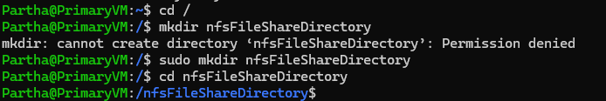

Allow access to created shared directory (am allowing all permissions)

>> chmod 777 directory-name

To see directory details with access permissions

>> ls -l

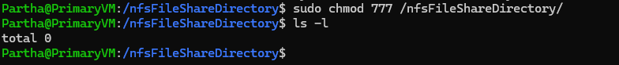

* Define to which cient (ip or hostname or * (* is for all clients in network)) which directory we are going to share with what all permissions .

Permission access permission should be inside /etc/exports/

>> **sudo nano /etc/exports**

>>i

>> /nfsFileShareDirectory *(rw,sync,no_root_squash)

Location :- /nfsFileShareDirectory

Client :- * (all)

Rw:- read and write files

Sync:- client changes sync to server

No_root_squash :- It allows the root user on the client machine to have the same level of access to files on the NFS share as any other user, potentially providing unrestricted access to the entire file system.

Restart nfs-server to take changes

>>sudo systemctl restart nfs-server

Export changes

>> sudo exportfs -rv

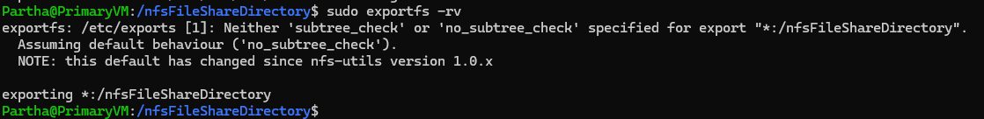

1. Client side configuration

* Install NFS packages

>> sudo apt install nfs-common

* Check **rpcbind** and **nfs-common** services a running

>>systemctl status rpcbind

>>systemctl status nfs-common

>>lsmod | grep nfs

lsmod | grep nfs to check the status of the services and kernel modules.

* Stop firewall for both nfs server and client

>> sudo ufw status

>> sudo ufw disable

* Check the server is mount or not

Run on nfs client machine

>> showmount -e nfs-server-ip

Cmd to see server ip

>> dig +short myip.opendns.com @resolver1.opendns.com

